Mindfulness

Tools to help you focus on just one thing for a few minutes. Give your brain a chance to catch up, refresh and clear your head so that you can look at your day in new light.

Name of App | Features | QR Code
Colorfy | Free pictures each day.  Colour one of your own pictures from your camera roll.  Create your own designs with images and text. | 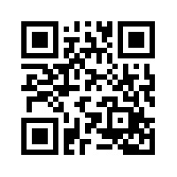
Breathe2Relax  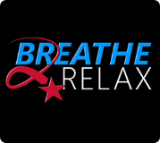 | Breathing exercises to calm yourself down.  Videos about mindful breathing.  Track your feelings before and after the exercises. | 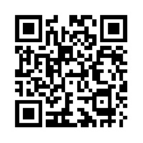
Stop Breathe & Think  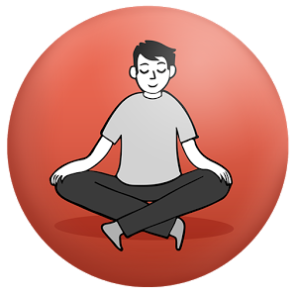 | Guides you through mindful meditation | 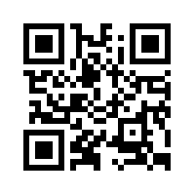
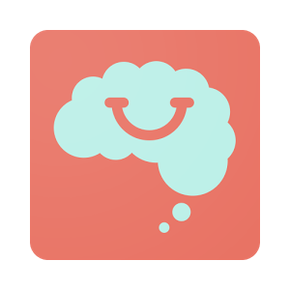  Smiling Minds | Track your emotions  Guided meditation.  Mindfulness programs for different age groups. | 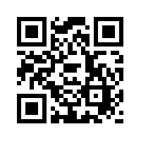

Mental Health and Moods

Tracking your moods can be important to help you identify your feelings, look for patterns,
find triggers and solve problems.

Always There  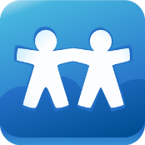 | Track your feelings.  Connect with local resources.  Live chat with Kids’ HelpPhone.  Stress buster jokes and tips.  Short articles on mental health topics. | 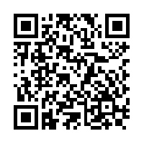
Booster Buddy  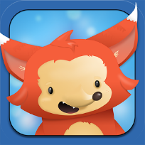 | “Mental Health Tamagochi”  Good for younger students.  Do activities to earn coins, then buy accessories for your character.  Daily quests to help you establish positive habits.  (Might work for some learning Centre students or younger children). | 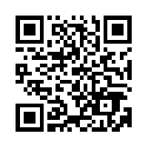
Mindshift  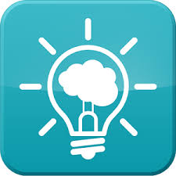 | Resources on different topics.  Identify personalized situations and create solutions on how to overcome them.  Contains visualizations and strategies to lessen your anxiety.  Inspirational quotes. | 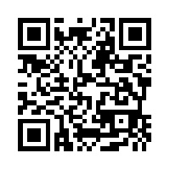
Unstuck  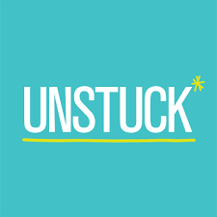 | Create an account.  Takes you through a series of questions (done in a fun way) to help you identify a problem, then gives suggestions to work on the problem.  -only avail. on iPads | 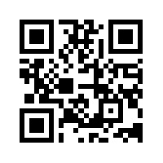
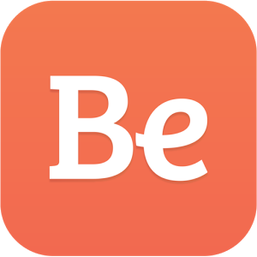  Be Safe | A digital safety plan.  Identify people you can call in an emergency.  Identify things that calm you in a crisis.  Has some info about local resources.  (by Mind your Mind) | 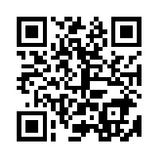

Physical Health

Your physical health is directly related to your mental health.

7 Minute Work Out | 2 different workouts for 7 minutes each.  Has videos to show how to do the exercises.  Many more workouts available in app purchases. | 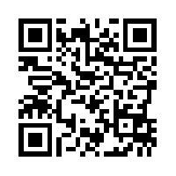
Sleep Pillow  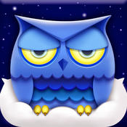 | Various white noise sounds for calming your mind before bed. | 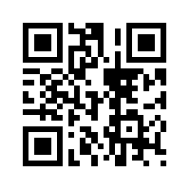
Clue Period Tracker | Track / predict your menstrual cycles.  Track your emotions, sexual activity, food cravings.  -Phys Ed classes | 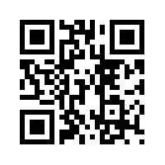

School Apps

School can be overwhelming and a trigger for people.
Taking control of school can help to take control of your mental health.

My Homework  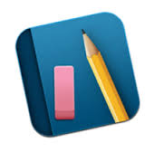 | Track assignments and tests.  View in calendar form or list form.  Sort assignments by class.  Create Reminders. | 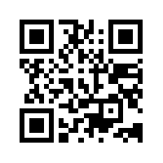
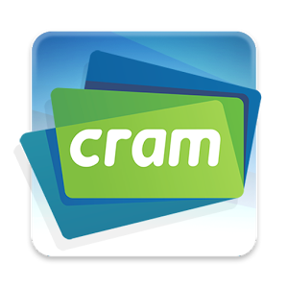  Cram | Create personalized flashcards.  Audio can read the cards.  Different “modes” to study from.  Access to a website that has other people’s cards already loaded. | 